**Newcastle Libraries Online Maker Tutorial:**   
**A Book Retold: Upcycle Book Sculpture**  
**With Leesa Maree Brock**

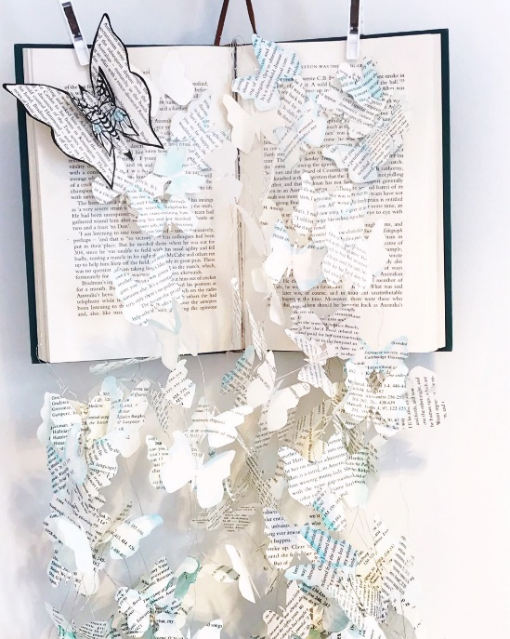

**Materials List and Step by Step Instructions**

**Materials List**

* One hard cover book
* Ribbon or string that will hold the weight of the book for hanging
* Two bulldog clips or wooden pegs to secure pages together
* Normal scissors or small curved nail scissors
* Pencil, eraser and ruler
* Paper cut knife
* Cardboard or thick paper
* Paint, paintbrush or inky pens
* Double sided sticky tape
* Needle or pin
* 30 gauge round silver plated copper wire. You can order this at Inspirewithwire.com.au or buy at your local craft shop. If you can’t get out and about why not recycle and experiment with fishing line from the shed

**Step by Step Instructions**

# Open YOUR hard cover BOOK TO THE CENTer PAGE

## **Use your paper cut knife safely and focus on removing 15 pages from either side of the book in three sections (5 pages per section) to create space for placement of wire pieces. This will create three gaps on either side with 30 pages altogether removed. Place string or ribbon around the inside of the spine to tie ready to hang. Add one bulldog clip or wooden peg to secure pages on either side at the top of the book.**

### Pages can be torn out if you do not have a paper cut knife. If you do have a paper cut knife practice mindful making with 100% focus on the task at hand for safety. If distracted stop what you are doing until 100% concentration is restored.

### It is in these gaps where the pages are removed that you will use double sided sticky tape to place your wire after butterflies have been threaded on. You will be securing between three and four wire/ butterfly pieces depending on how much volume you want to create.

### Wire length will be determined by you, but it is recommended that the length will reduce as you move closer to the front pages of the book to add volume.

# Pick out your butterfly shape and draw on cardboard

## **Take a rectangular piece of cardboard 23cm in height by 7cm width and draw a butterfly shape 5cm in height and 6cm in width. This should fit 4 butterfly drawings on your cardboard and there are plenty of templates on Pinterest or in insect books from your local Library to choose from.**

### Fold rectangular cardboard in half and on one side draw half your butterfly wing and insect body. Use scissors (I like using curved blade nail scissors) to cut out outline and this will remove the butterfly for your first template outline. I recommend folding cardboard as this ensures both butterfly wings will be exact once cut. With the cardboard butterfly removed repeat three more times tracing the outline of the removed cardboard butterfly cut out, so you have four butterfly outlined templates on cardboard.

### With cardboard template use pencil to draw your butterfly on page 8 times and cut out of stacked 5 pages to make 40 butterflies. Use pages removed before from book. You should be able to cut through 5 pages, otherwise, reduce stack.

### With these cutout butterflies add paint if you like or draw a design with inky pens. Experiment and channel your creativity to make it your own signature design.

### Use pin to puncture two small holes into center of butterfly where will thread through wire.

### Kink wire a little to secure each butterfly in place. For extra super security use jewelers’ crimps and flatten on wire with crimping pliers after each paper butterfly. For the end of the wire fold at the back of the butterfly to wrap around wire and then thread back under wire at back of butterfly to then cut for no wire to be sticking out. The wire is easily sculpted and will hold in place.

# placement of wire pieces

## **Cut small piece of double-sided sticky tape (No more than two cm long) to place wire pieces inside the gaps that you previously made and place in the bottom half of the book on either side. Once three or four wires are stuck down close page to secure flat. Then complete on other side.**

### You will reduce the length of wire pieces as you make your way to the front pages of the book.

### Sculpt wire and shape butterfly wings either open or flattened together as you like.

### As your last wire pieces are placed on the front page place a single butterfly to cover up the bare double-sided sticky tape. Add more single butterflies to taste.

# create big butterfly feature

## **Draw with pencil a large butterfly on book paper and cut out. With double sided sticky tape place another small butterfly on top. In this design I have used black ink pen and a touch of watercolour to decorate, however, use your creative license to express your creative flair.**

### Place featured butterfly on the top right-hand corner of the left front page with double sided sticky tape to secure. Check in with completed work to sculpt wire as needed until you get that sense of wholeness which states the composition is completed.

### Well done! You have just completed your first upcycle book sculpture.

### For more inspiration you will find artist Leesa Maree on:

### Website: [www.templelah.com](http://www.templelah.com) Instagram: Temple_Lah